# Installation Guide Kaleidoscope

## Prerequisites

This guide is based on the assumption that there is a Linux server or virtual machine in place running an Ubuntu (or Debian) installation and being able to login to the machine via SSH (or direct console) with a user having SUDO permissions.

## Installation of Packages

# sudo add-apt-repository -y ppa:ondrej/php

# sudo apt-get update

# sudo apt-get -y upgrade

# sudo apt-get -y install apache2 libapache2-mod-php5.6 php5.6-gd php5.6-imagick php5.6-curl php5.6-mysql mysql-server git npm nodejs-legacy

# npm install --global webpack

During installation mysql will ask you to provide a root-Password, please note that down.

## Configuration of Apache and its modules

# sudo a2dismod mpm_event

# sudo a2enmod rewrite php5.6

Most probably it is also a good idea to enable mod_ssl and configure it with the appropriate certificates that are validate within your organization’s network.

Set memory limit, post limit, and max upload size to a value that supports the upload of large files to wordpress.

sudo sed -i.orig 's/upload_max_filesize\ \=\ 2M/upload_max_filesize\ \=\ 512M/g' /etc/php/5.6/apache2/php.ini

sudo sed -i.orig 's/post_max_size\ \=\ 8M/post_max_size\ \=\ 512M/g' /etc/php/5.6/apache2/php.ini

sudo sed -i.orig 's/memory_limit\ \=\ 128M/memory_limit\ \=\ 768M/g' /etc/php/5.6/apache2/php.ini

## Wordpress installation

Download wordpress installation files from e.g. <https://wordpress.org/latest.tar.gz>. Untargz this under /var/www/html. If Apache/PHP/MySQL is running as expected, you will now be able to install wordpress using their web-interface. It will guide you through the process.

## Wordpress configuration

Once wordpress is installed, access the backend <http://hostname/wp-admin> and go to the plugins page. Make sure the plugins listed below are installed. You will need a license for Advanced Custom Fields Pro.

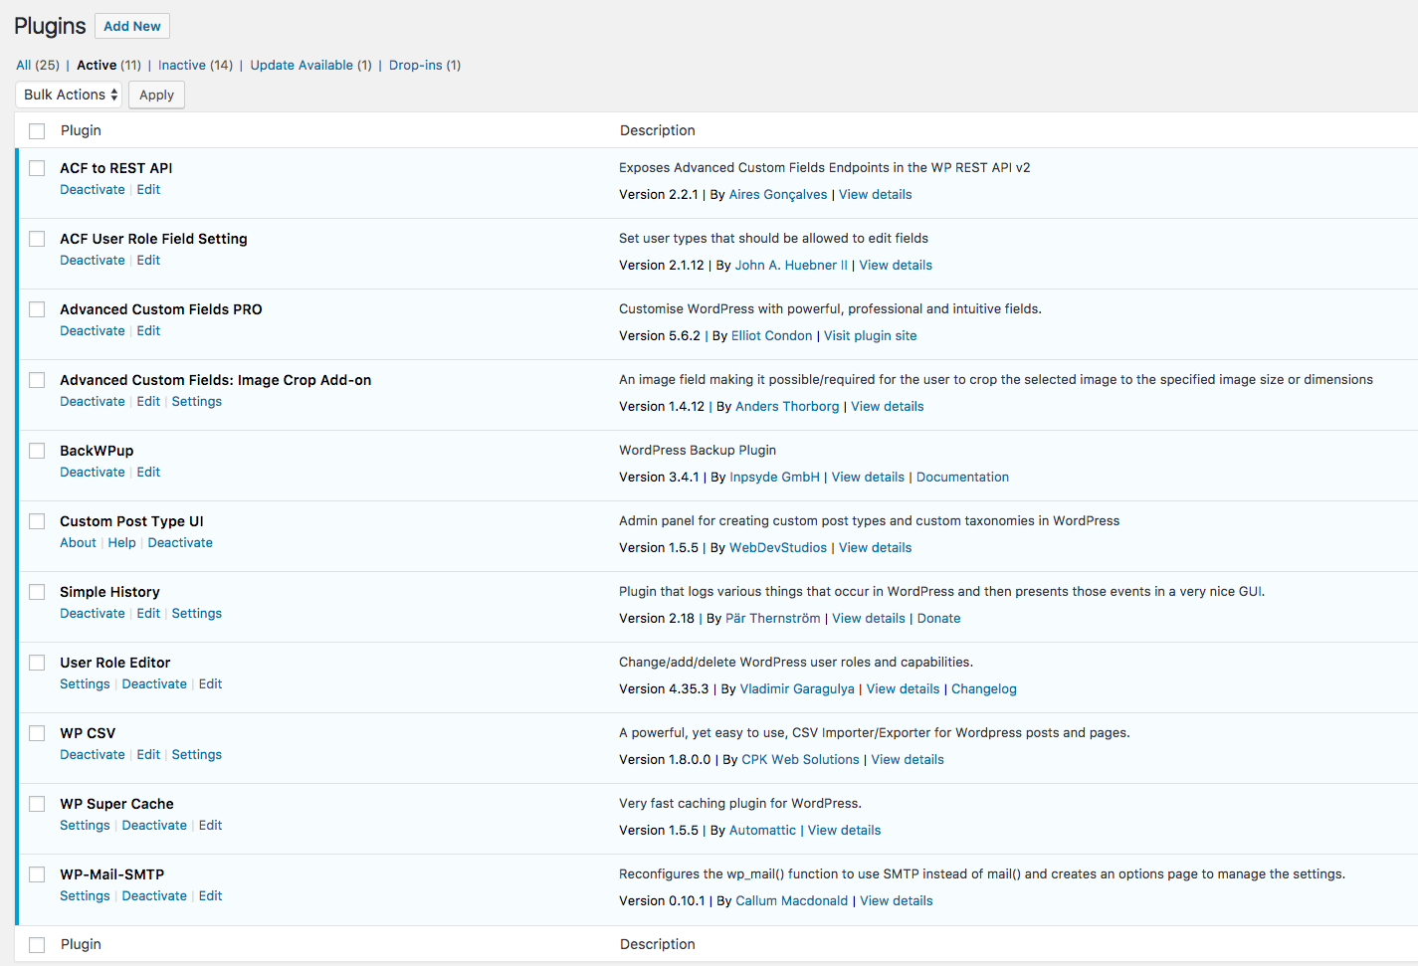

When ACF pro is installed, use file “acf-export-xxxx-xx-xx.json” to upload and import the field descriptions.

## Installation of Kaleidoscope theme

Get Sources from github.com and check them out into /var/www/html/wp-content/themes/kaleidoscope. Run webpack in this directory.